Bahria University,

Karachi Campus



LAB EXPERIMENT NO.

**04**

LIST OF TASKS

|  |  |
| --- | --- |
| TASK NO | OBJECTIVE |
| 1 | **Using python implement Decision Tree Algorithm on Heart Attack Analysis & prediction dataset to predict the chances of heart failure in a person. visualize the results of the model in the form of a confusion matrix using matplotlib and seaborn.** |
| 2 | **Using Knime implement Task # 01.** |
| 3 | **Using python perform the parameter tuning to optimize the Decision Tree performance and compare the results with task # 1.** |

**Task 1: Using python implement Decision Tree Algorithm on Heart Attack Analysis & prediction dataset to predict the chances of heart failure in a person. visualize the results of the model in the form of a confusion matrix using matplotlib and seaborn.**

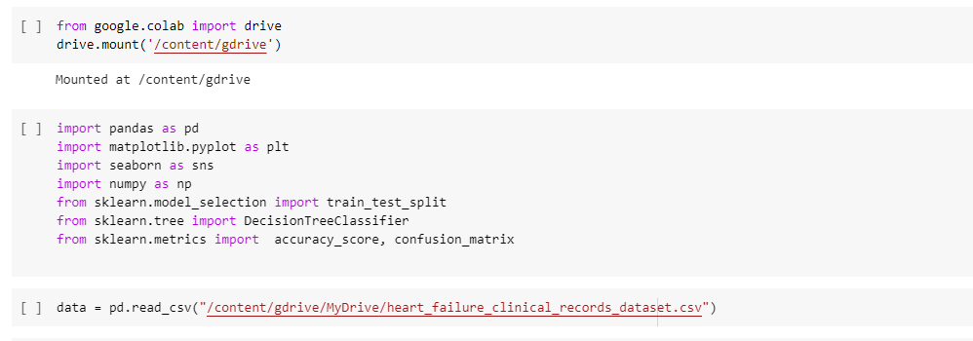

**Task 2: Using Knime implement Task # 01.**

**Task 3: Using python perform the parameter tuning to optimize the Decision Tree performance and compare the results with task # 1.**



